**Tech Stack:**

Front End**: React JS and Redux**

Backend **: Node JS**

Database: **Mongo on Cloud**

**Execution Instructions**

**To run app:**

**Step1** - Do an **npm install** inside ‘ui’ folder

**Step2** - On terminal, run comand **npm run start**

**To run Node API:**

**Step1** - Do an **npm install** inside ‘APIService’ folder

**Step2** - On terminal, run comand **npm run start,** or hit launch(play button)in VS code

**Sample credentials to login (or use Google Login):**

**Site URL:** <https://magictricks.azurewebsites.net/> **Username**: [james@sapiens.com](mailto:james@sapiens.com)  
**Password**: james

**Design thought:**

1. User will be able to log in via their custom login credentials , or, via Google login
2. All logged in users can buy and sell property
3. Once logged in, user will see 3 options:
   1. Buy- To buy any available properties (except his own property)
   2. Sell – To upload a new property for other users to see under their ‘Buy’ section
   3. My Properties – To see list of their own uploaded properties
4. Feature to upload his own property details for listing– Form will have necessary client side validations like mandatory fields, number type field, etc.
5. User has the option to filter properties based on Budget, Property type and text based search
6. User can go to Detail view of the property from the listing (Buy/Sell Properties view) view to see more details.

**Screenshots below:**

**Login Page**

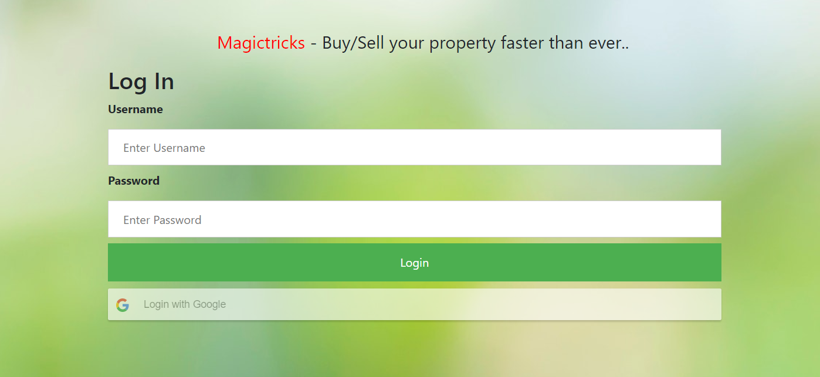

**Home page of logged in user:**

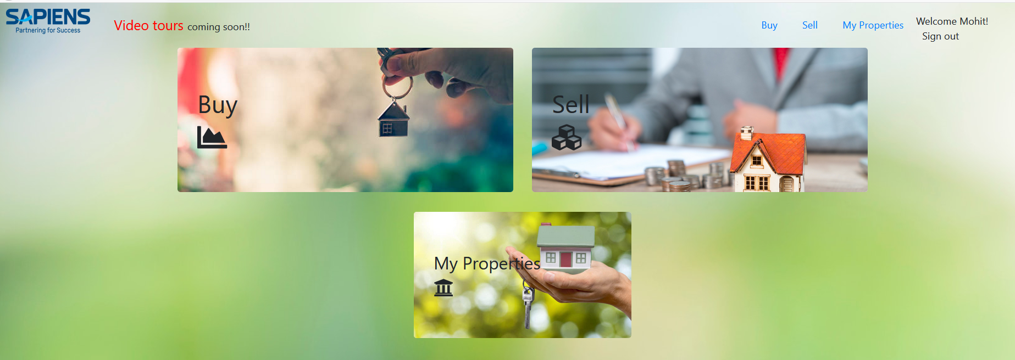

**‘Sell Property’ view**

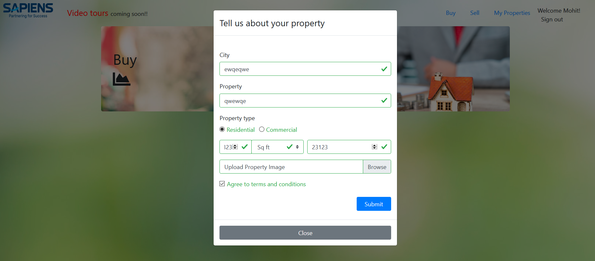

**Buy /My Properties view - with filters**

